**Shift Roster Generator – Guide**

1. Create a path C:\temp\Roster
2. Keep below attached files ‘Roster_Automation.py’, ‘oncall-schedule.PNG’ and ‘Input_Data.xlsx’ in C:\temp\Roster

 

1. Input_Data.xlsx contains information of resources and holidays (IND and US). (Had to separate resources based on roles for manipulation of data inside the script)

Resources Tab

|  |  |  |  |
| --- | --- | --- | --- |
| IND | US | DutyManager | TL |
| A | D | P | X |
| X | E | Q | Y |
| B |  |  |  |
| Y |  |  |  |
| C |  |  |  |

Holidays Tab

|  |  |
| --- | --- |
| India | US |
| 2020-01-01 | 2020-01-01 |
| 2020-01-15 | 2020-01-20 |
| 2020-02-21 | 2020-05-25 |
| 2020-03-25 | 2020-07-03 |
| 2020-04-10 | 2020-09-07 |
| 2020-05-01 | 2020-11-26 |
| 2020-05-25 | 2020-11-27 |
| 2020-07-31 | 2020-12-25 |
| 2020-10-02 |  |
| 2020-10-26 |  |
| 2020-11-13 |  |
| 2020-12-25 |  |

1. Keep the python package installed along with “PIP”, “openpyxl” and “pandas” module to run the above script Roster_Automation.py. Also make sure environmental variables are configured for python.
2. Launch command prompt and cd to C:\temp\Roster and run below

“Python Roster_Automation.py”

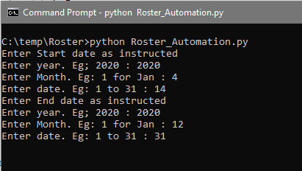

1. Once the script is executed, find “roster.xlsx” generated at C:\temp\Roster

